GAMR3531 Report Template
Repo URL: | https://github.com/GAMR3531/cw26-beani3/tree/baseProfile |  |  |  | Commit: | 9bd2dc711b80d2a438ff5693eadac5629ba4b22e
Tick all parts of the submission that this report covers:
GPU | Profile run and documented but no changes made. | All redundant binding of GPU buffers and shaders removed. Profile run and documented for this change. | Successfully Implement either a depth-pre pass or move to deferred or tiled rendering. Profile run and documented. | Successfully Implemented a LOD scheme. Profile run and documented. | Successfully Implemented instanced rendering. Profile run and documented. | Rewrite the Bloom effect in compute shaders or GPU side frustum culling in a compute shader.  Profile run and documented. | Innovation beyond the specification.
 | ☐ | ☐ | ☐ | ☐ | ☐ | ☐ | ☐
CPU | Profile run and documented but no changes made. | Replace polymorphic games object with composable game objects.  Profile run and documented. | Minimised memory footprint of all classes.  Improve memory use of UBO/UBOManager. Profile run and documented. | Successfully implemented SIMD collision checks (beyond default/GLM optimisation) or CPU side frustum culling.  Profile run and documented. | Successfully Implemented a spatial partitioning scheme for broad phase collision checks. Profile run and documented. | Manually manage all RAM allocations with a sensible scheme.  Profile run and documented. | Innovation beyond the specification.
 | ☐ | ☐ | ☐ | ☐ | ☐ | ☐ | ☐
What change(s) have you made:

Which tools have you used to provide evidence for the change(s) you have made? |  | ☐ | Tracy
 |  | ☐ | RenderDoc/NSight
 |  | ☐ | Custom instrumentation
 |  | ☐ | Other (please state)
Put your Evidence here: |  | 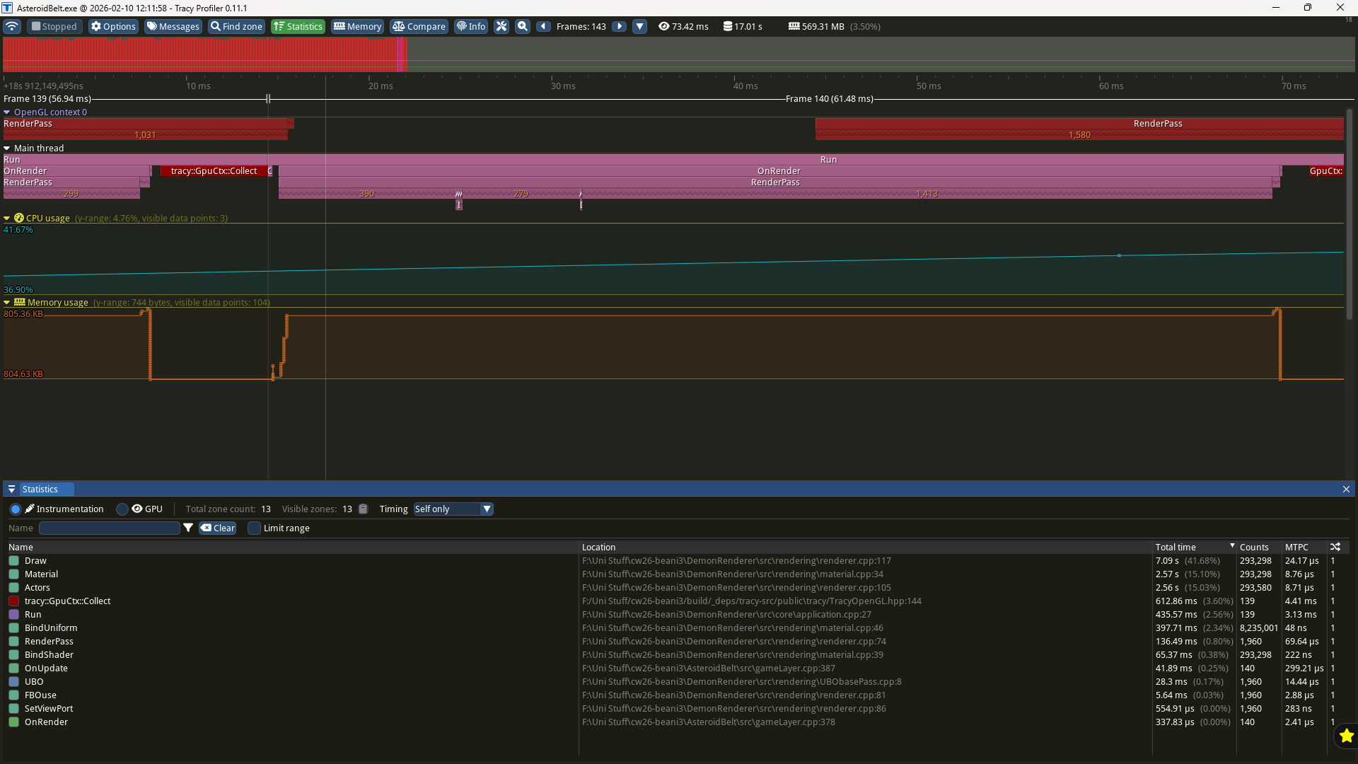
Anything else you want to add?

